**D1 – Evaluate the suitability of object oriented programs for graphical applications**

**Introduction**

In this report, I will evaluate whether Object Oriented programs would be suitable for graphical applications.

**Graphical Application**

This game is called ‘ON THE RUN’. As you can see on the picture, the yellow car shown is the main car used within the game. The yellow car is used to run around the map until the game ends. The black and white van is used as distraction. The vans can damage the car until it stops working. Once the yellow car stops working, the game ends. Furthermore, at the top of the screen, the car’s fuel and car is monitored. Figure 1.1 shows how it is monitored. Once it goes in the red area, you need to fill it up by picking a sign up. If the car is in the red area, the car blows up and the game ends.

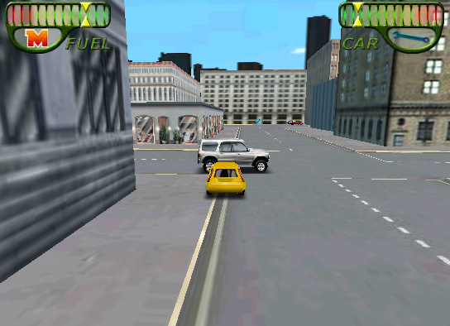

Figure 1.1

[](http://www.google.co.uk/url?sa=i&rct=j&q=&esrc=s&source=images&cd=&cad=rja&uact=8&ved=0CAcQjRw&url=http://whuzupblog.com/category/games/miniclip/&ei=fmF1VfGoKMiX7Ab9yYPQDA&bvm=bv.95039771,d.ZGU&psig=AFQjCNFmaPqBrOIqNnuyWE_0rEXpkSLehw&ust=1433842427934860)

**Keys:**

* UP = MOVE FORWARD
* LEFT = MOVE LEFT
* RIGHT = MOVE RIGHT
* SPACE = BREAK

Figure 1.2

* MOUSE to CLICK ‘Play’

**Action**

The action for this game is to use the keys to start the graphical application. UP, LEFT, RIGHT, SPACE and MOUSE enables the game to trigger an action. For example, the first action used is the mouse to click Play. Once that is done, UP; LEFT, RIGHT is used.

**Trigger**

The trigger is once the keys is pressed, it enables the graphical application to recognise you did something

**Event**

The event is what the key is pressed. If I pressed UP key on the keyboard, it will enable the car to move forward. The keys shown above shows the event.

**Suitability of Object Oriented programs for graphical applications**

Object Oriented Programming is suitable for graphical application by it having many advantages including:

* **Maintainability**

In programming, a change to one part of the program can often directly affect other parts. By designing an application as a collection of components, the dependencies between the different parts of the system are reduced to the data passed between components. Changes to an application are isolated to the affected components and do not require you to re-release and retest the entire system, just the component.

* **Scalability**

Scalability allows you to add features without writing the whole code again. This enables codes to be written very quickly and effectively.

* **Reusability**

Some of the content can be reused. Especially for graphical applications, content is going to be repeated at the start. For example, if I were to walk in one world, I would need to be the same if it was going to be for another world. The code is going to be the same, but of course, the background is going to be different.

Furthermore, you can use objects again. For example, in On the Run, the movement of the car is an object alongside the other objects. Once all the objects are put together, they make the game.

Object Oriented is suitable for graphical applications; like On the Run. This is because it can enable goals to be achieved. For example, if I want a car to run from one end to another, it can be done by using Object Oriented Programming. In addition, by coding a graphical application can be very long. Some parts of the code will repeat one way or the other. The advantage for using Object Oriented is that some parts of the code do not need to be rewritten. This allows the programmers to write less code and make the application faster.

**Conclusion**

In conclusion, I feel it is suitable for object-oriented programming to be implemented. The main reason is that it is suitable for graphical application, because the user can see the graphical interface. The user knows what is going on. If anything is gone wrong, the user can fix it.